***Practice Week 4th***

*SaaS, PaaS, IaaS*

Cloud Services (Introduction)

Teacher: Mr. Zheng Li

Student: Juan Albornoz

## Task 1:

* 1. By rewriting the lambda function and implementing timers for measuring the latency I did it this way:
  2. 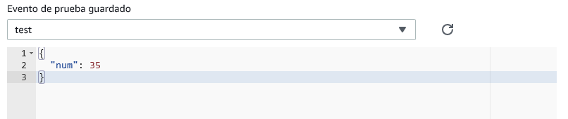Also the test event used:
  3. 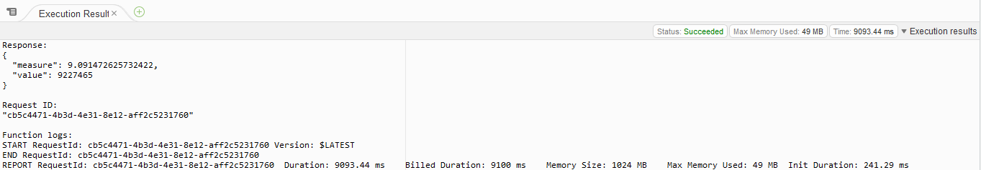The output for the latency:

*Observations of troubleshooting:

* Execution problems in Lambda with the 3 seconds limit of time latency setted in the Basic Settings, aborted the execution when that time is reached.
* Time limit changed to 15 seconds

## Task 2:

* 1. Setting up the EC2 instance on Ubuntu Server 20.04 Volume type from AWS:
  2. 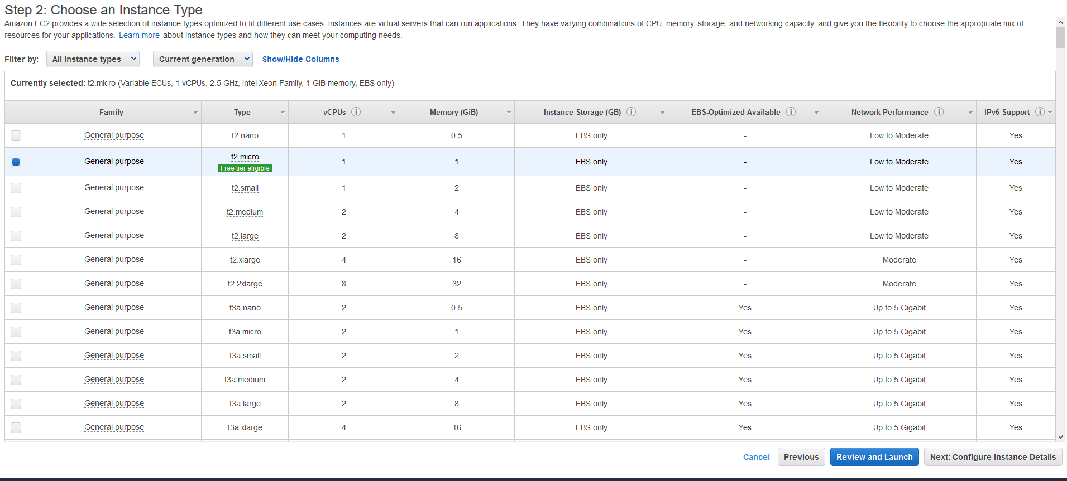 Selection of the instance type, I chose the default recommended by the platform:
  3. 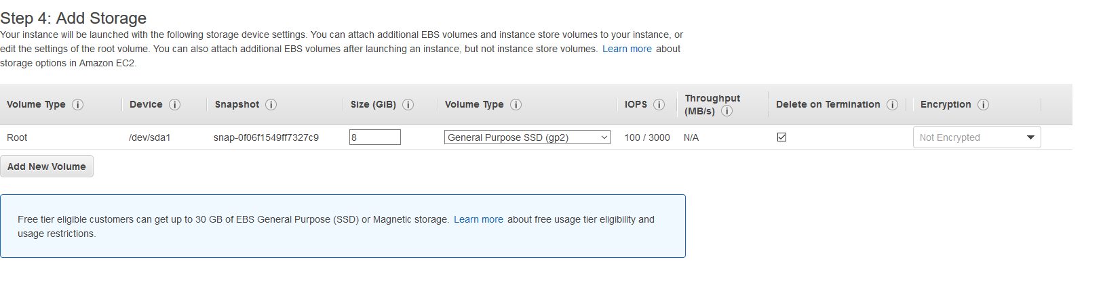 Modified the size of the storage from 8Gb to 30Gb just in case:
  4. 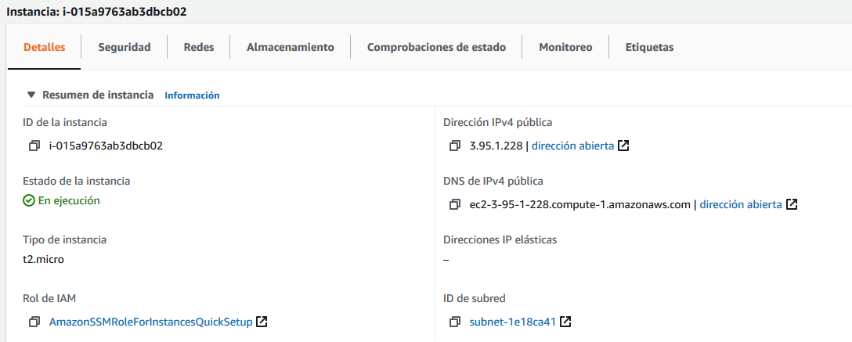 The instance is launched and it has a public IP DNS for accessing it. It’s important to notice that the process builded a key file .pem to access.
  5. In the shell using the next command it’s possible to access to the EC2 instance by secure shell command:

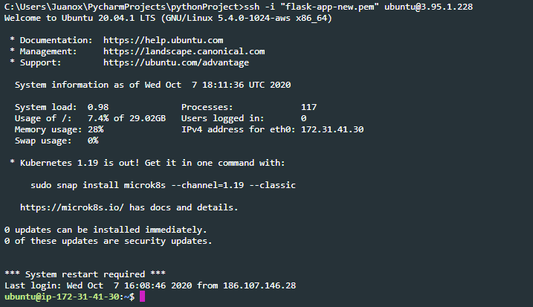*>> ssh -i "flask-app-new.pem"* [*ubuntu@3.95.1.228*](mailto:ubuntu@3.95.1.228)

* 1. 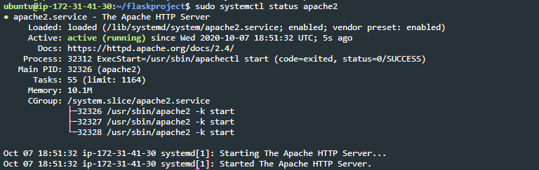After installing all the dependencies I can mount the Apache2 server: (Dependencies: apache2, libapache, pip3, flask).
  2. Have the both files in the app directory *flask-app/* for building the flask application:

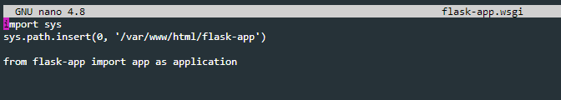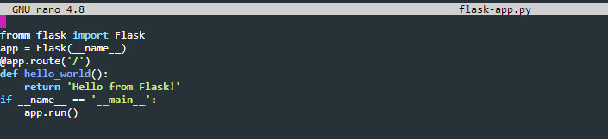 *flask-app.py & flask-app.wsgi (Hello world just for testing)*

* 1. Modifications in the *000-default.conf* file from apache2 directory:
  2. Flask application should be deployed but it shows me an Internal Server Error. I tried it in the next adresses:

[http://ec2-3-95-1-228.compute-1.amazonaws.com](http://ec2-3-95-1-228.compute-1.amazonaws.com/flask-app/)

http://ec2-3-95-1-228.compute-1.amazonaws.com/flask-app/

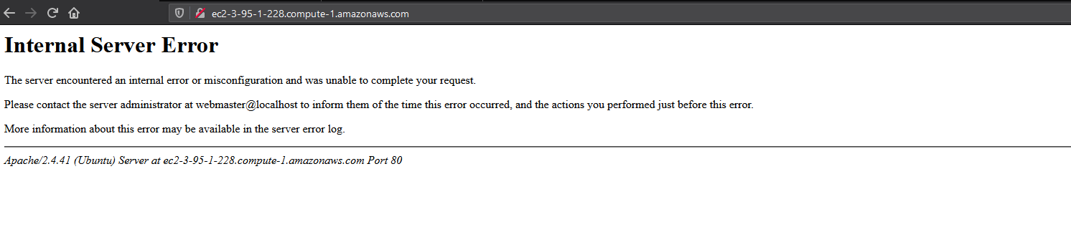

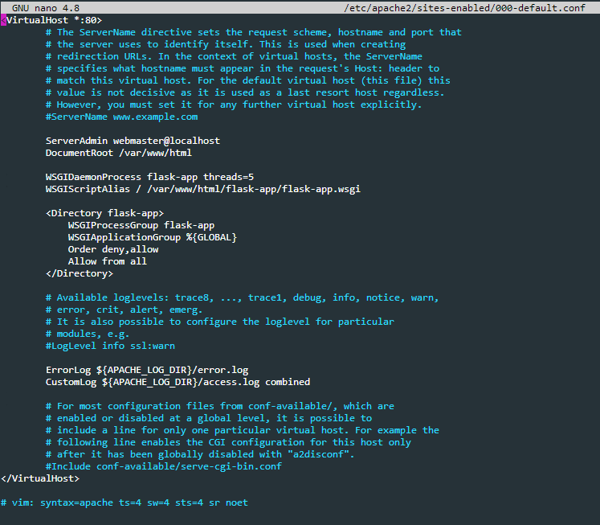

*Some logs from apache2 in the Ubuntu machine. I think it’s just a directory declaration problem from python syntax in my .wsgi file (I’m still getting acquainted with python)

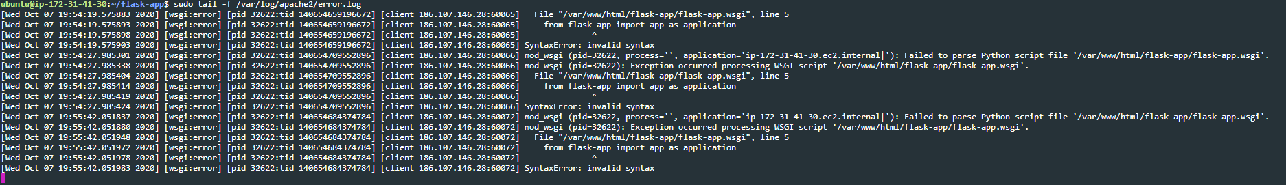

## Task 3:

I think that there are important differences between the right use-case for EC2 and Lambda. Since EC2 requires to manage a complete environment resources (Infrastructure-as-a-Service), these aren´t just the OS, but a copy of all the hardware the OS needs to use, so I think EC2 it’s on another scale in comparison with Lambda AWS.

Lambda just require the resources to run an specific programming task and it makes this service more kind of “portable” for development and deployment so it’s more defined in terms of function-as-a-service.